**Course** **:** LP-III (Blockchain Technology) **Class :** BE-4

**Batch** **:** R4

**Group Members :** 1) Anuj Mutha (41443)

2) Nidhi Patil (41447)

**Problem Statement:**

Mini-Project- Develop a Blockchain based application- Student Attendance Management System using Smart Contract and deploy it using Ethereum

**Objective:**

Understand and explore the working of Blockchain technology and its applications.

**Course Outcome:**

CO6: Interpret the basic concepts in Blockchain technology and its applications.

**Description:**

Smart contracts are simply programs stored on a blockchain that run when predetermined conditions are met. They typically are used to automate the execution of an agreement so that all participants can be immediately certain of the outcome, without any intermediary’s involvement or time loss. They can also automate a workflow, triggering the next action when conditions are met.

A smart contract is just a digital contract with the security coding of the blockchain.

* It has details and permissions written in code that require an exact sequence of events to take place to trigger the agreement of the terms mentioned in the smart contract.
* It can also include the time constraints that can introduce deadlines in the contract.
* Every smart contract has its address in the blockchain. The contract can be interacted with by using its address presuming the contract has been broadcasted on the network.

The idea behind smart contracts is pretty simple. They are executed on a basis of simple logic, IF-THEN for example:

* **IF** you send object A, **THEN** the sum (of money, in cryptocurrency) will be transferred to you.
* **IF** you transfer a certain amount of digital assets (cryptocurrency, for example, ether, bitcoin), **THEN** the A object will be transferred to you.
* **IF** I finish the work, **THEN** the digital assets mentioned in the contract will be transferred to me.

**Code:**

pragma solidity ^0.4.18;

contract Owned {

address owner;

function Owned() public {

owner = msg.sender;

}

modifier onlyOwner {

require(msg.sender == owner);

_;

}

}

contract AttendanceSheet is Owned {

struct Student {

uint age;

string fName;

string lName;

uint attendanceValue;

}

mapping (uint => Student) studentList;

uint[] public studIdList;

event studentCreationEvent(

string fName,

string lName,

uint age

);

function createStudent(uint _studId, uint _age, string _fName, string _lName) onlyOwner public {

var student = studentList[_studId];

student.age = _age;

student.fName = _fName;

student.lName = _lName;

student.attendanceValue = 0;

studIdList.push(_studId) -1;

studentCreationEvent(_fName, _lName, _age);

}

function incrementAttendance(uint _studId) onlyOwner public {

studentList[_studId].attendanceValue = studentList[_studId].attendanceValue+1;

}

function getStudents() view public returns(uint[]) {

return studIdList;

}

function getParticularStudent(uint _studId) public view returns (string, string, uint, uint) {

return (studentList[_studId].fName, studentList[_studId].lName, studentList[_studId].age, studentList[_studId].attendanceValue);

}

function countStudents() view public returns (uint) {

return studIdList.length;

}

}

**Output:**

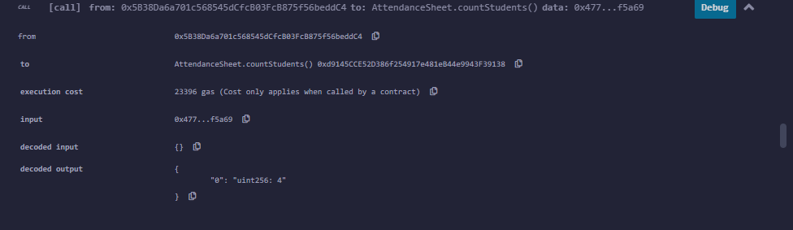

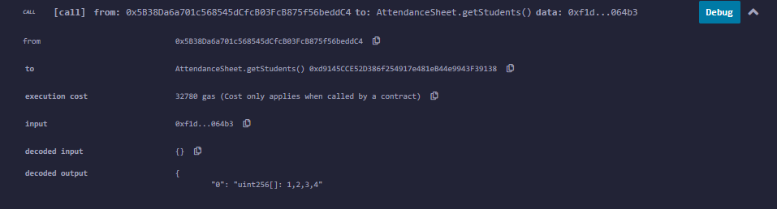



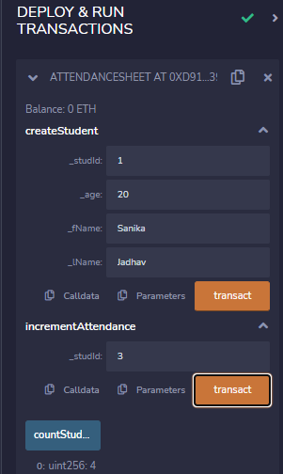 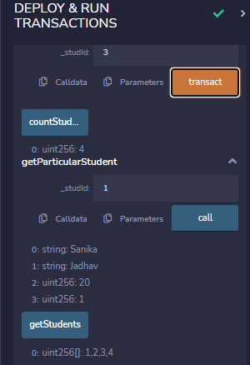

**Conclusion:**

I studied about smart contract and how to write and execute it using Remix IDE.